**Activity 3: Hi-Fi Prototype and links to people-centered design**

For this activity, we split our workload into 3 parts. We also assigned an idea behind the design of each part to each person. The ideas were assigned as follows; Gestalt – Kaden. Affordances – Wilbur, Constraints – Will. Below will provide a description of how these ideas were implemented into the HiFi prototype.

**Gestalt - Kaden**

The Gestalt principles focus on Figure and Ground, Proximity, Symmetry and Order, Similarity, Continuity, and Closure. A great resource that I found for this section and used to aid in my design was this article, [https://www.smashingmagazine.com/2019/04/spaces-web-design-gestalt-principles/#symmetry-and-order](https://www.smashingmagazine.com/2019/04/spaces-web-design-gestalt-principles/) .

To implement all of these features/concepts would have been a difficult task so I focused on implementing the following throughout the webpages I designed (Home, About Us, and Membership); Proximity, Symmetry, and Similarity, and one that I tried to do Continuity with.

**Proximity**

This concept is about the closeness of elements on a page. Grouping different elements together can create an association by proximity, even if similarity isn’t the highest. 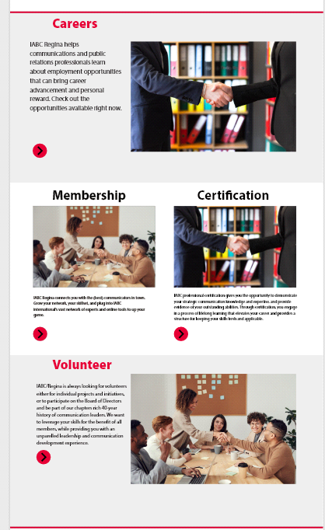

I implemented this concept on the home page with “Membership” and “Certification”. While this section also implemented similarity and symmetry, the proximity implies that they are related to each other.

**Proximity (cont.)**

I also applied proximity on the Membership page where I had green checkmark symbols beside the membership benefits list. This causes the checkmark and “good” feeling to be linked to the benefits listed.

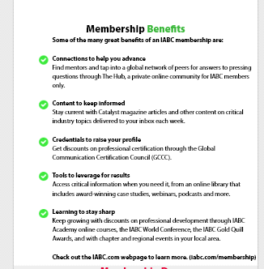

**Symmetry**

Symmetry is when an object if it can be divided into two or more identical pieces.

Again, this concept can be seen on the home page as seen in **my first example**. I have split up the sections into Career, Membership, Certification, and Volunteer. The coloring of the section breaks (red lines) and the titles of the section reflect symmetry as they do a mirror pattern (red line, red title, black title....). The pattern of 100, 50/50, and 100 for the section column sizes also reflect symmetry.

**Similarity**

Similarity is when objects share attributes such as color, shape, size, etc.

This concept can be seen on the Home page for the twitter and news feed. Here I implemented similarity by keeping them the same shape, and size. This makes them both feel and look similar.

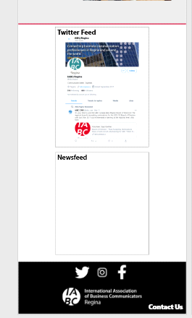

**Continuity (ish?)**

Continuity is about establishing a consistent path/pattern from object to object. Users will follow the most natural/least resistive path. This was fairly hard to implement, although I did find an example that I liked and think might link back to this.

I had saw an example of what I thought was something similar to this on a local pub’s website <https://www.pileobonesbrewing.com/about> . I still don’t quite know if this falls into “Continuity” or any Gestalt design principle. But the innate appeal of the design makes me think something psychological such as Gestalt is at play.

The design on the website linked above allows a user to read the bio and naturally look over to the image, which isn’t directly connected to the bio, but utilizes our natural left to right scan to link it. They list their staff with the bio on the left and the images on the right with different backgrounds.

Here was my attempt to do this. I have the bios on the left and the images on the right with a different background.

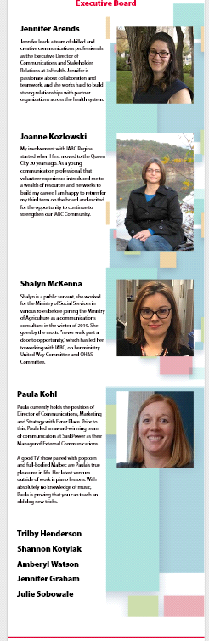

**Constraints – Will**

The idea of constraints in design is to limit the options which a user has in order to prevent unintended use of the system. There are multiple types of constrains: physical, logical, cultural and. One physical constraint can be seen on the careers page.

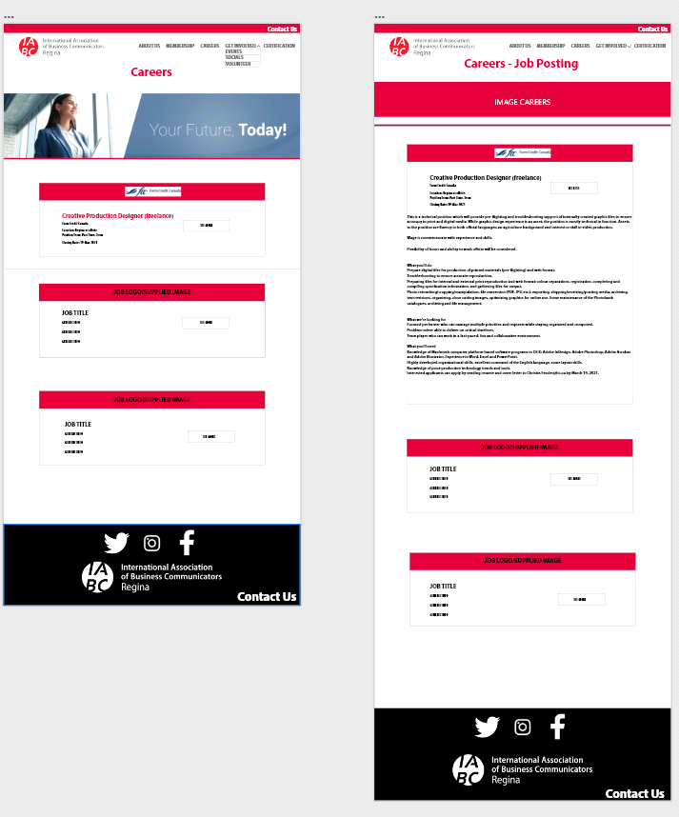

The careers page will first show boxes with general information about each career posting with a button prompting to “see more”. Clicking this button will automatically enlarge to a predetermined box size which will show all of the more in-depth information about the job. Not allowing the user to change the size of the box or scrolling through the box to see more is a constraint done in order to assure that the user does not miss any potentially important information about the job.

The same idea can be seen used on the Get Involved page with the Events boxes.

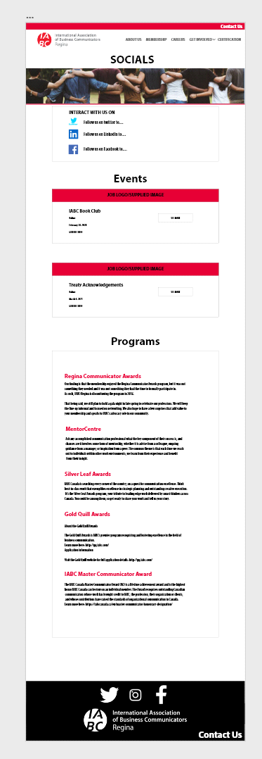

As this website is not the most robust system, there are not a lot of actions for a user to do outside of reading information or signing up for events which is handled externally. Because of this there is not a need for a lot of constraints.

**Affordances - Wilbur**

The idea of affordance revolves around the relationship between the design image and the actual purpose of the design itself. There are three types of affordances: Perceptible, Hidden, and False. Perceptible and Hidden types can be seen on the following pages.

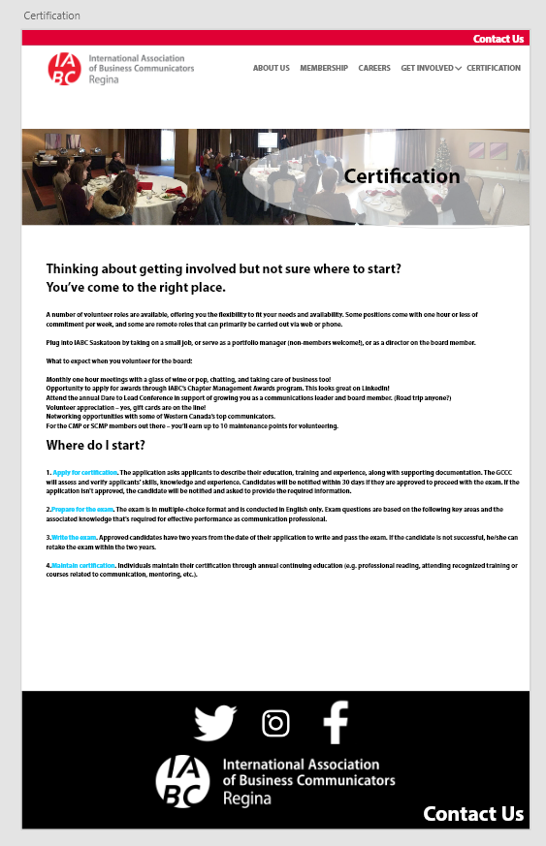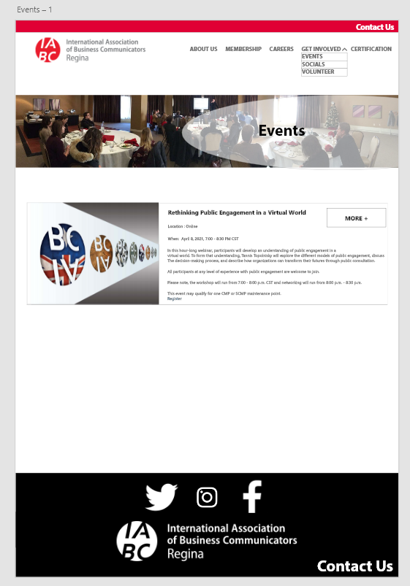

The downright arrow beside the 'get involved' navigation bar signifies that the button unlocks more navigation features which is part of the "Perceptible" type of Affordances. It indicates that there are other possibilities when clicking the "Get Involve" menu bar. Also, in the Events section the additional features that were added can be seen under the navigation bar. The events section briefly summarizes the upcoming events, upon clicking the 'more+' button it also unlocks additional information which is similar to the previous property mentioned.

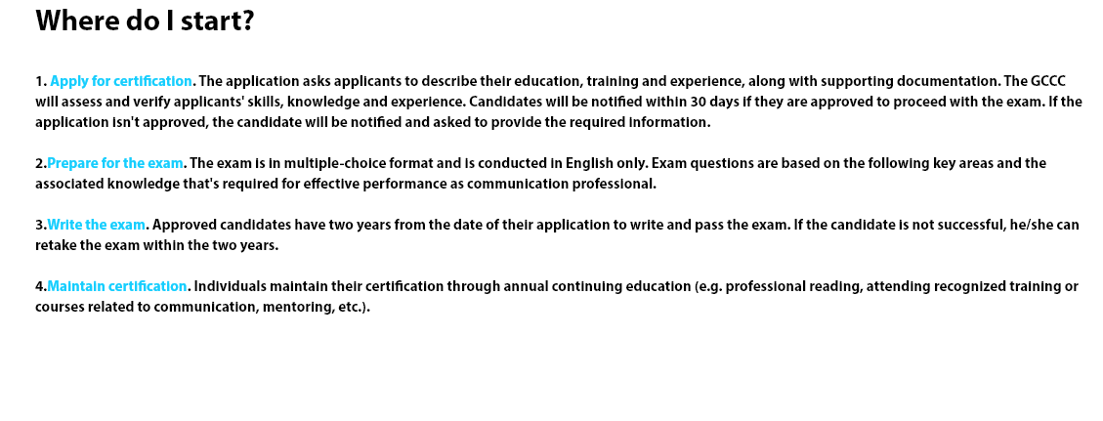Looking closely at the certification page there are sentences highlighted with blue color which signifies that they are clickable links that take the user to other pages. This type of affordances relates to "hidden" Affordances. People who are browsing the internet for the first time may not know that blue words highlighted words or sentences indicate that it is a link to another website. The users need to rely on their previous experiences or through trial and error to determine if there is a possible action connected with it.



The same idea is also applied to the footer of the High-fi that we created. People who have no prior experience in using the internet or computer may not know what these symbols mean. Therefore, a trial and error is needed to figure out what these symbols mean.